Stimulus-response model

A stimulus is a change in the environment that triggers a response (hot and cold, plant growing towards the sun). Receptors are specialised cells within our organs that detect the stimulus (receptors in your skin detect heat/pain).

|  |  |  |
| --- | --- | --- |
|  | External stimulus | Internal stimulus |
| Definition | Sensory stimuli which occur outside of the body | Sensory stimuli occurring within an organism |
| Types | * Pain and touch * Vision * Taste * Smell * Sound * Balance | * Blood pressure * Homeostasis (state of steady internal, physical, chemical, and social conditions maintained by living systems) |

Common stimulus:

* Smell
* Sight
* Sound
* Touch/pressure
* Taste

Sensory receptor organs

* Nose
* Tongue (Chemoreceptors)
* Ears (Baroreceptors)
* Skin (Thermoreceptors)
* Eyes (Photoreceptors
* Internal organs

An effector is a muscle, gland or organ that carries out a response that is produced as a result of stimulus, e.g., eyes (effector) crying (response) after chopping an onion (stimulus) detected by pain receptors in the eyes.

**Steps in the stimulus response model**

1. The stimulus is detected by receptors.
2. The message is carried to a control centre to understand the message (such as your brain)
3. The control centre sends a message to the effector (an organ, gland, or muscle)
4. The effector responds.

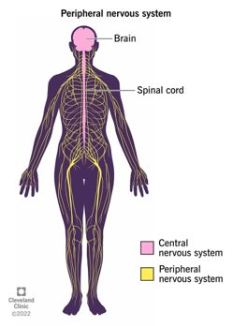**Cells and the stimulus response model**

Cells need to communicate with each other, and with different tissues and organs to support body systems to function. The main body systems related to stimulus response communications between cells are the nervous system and the endocrine system.

Nerves send electrical impulses and chemical messengers (neurotransmitters) between the brain and the rest of the body. These impulses hep feel sensations and move muscles. They also help with eating, breathing, sweating and digesting food.

**How do neural messages travel in the nervous system?**

**Neuron and Nerves**

Nerve: Enclosed, cable-like bundle of axons and nerve fibres found in the peripheral nervous system. Types: autonomic nerves, motor nerves and sensory nerves.

Neuron (nerve cell): individual specialised cell which are primarily involved in transmitting information through electrical and chemical signals. Found: brain, spinal cord, and the peripheral nerves.

**What are nerve fibres?**

Nerve fibres are bundles of nerve cells also known as neurons (neurons pass electrical signals to and from the brain) that pass electrical signals (impulses) to the brain. From the central nervous system (CNS), nerve fibres send impulses to effectors (muscles/glands).

**Neurons**

There are three types of neurons,

1. Sensory neuron – carries impulses from the receptors to the spinal cord.
2. Interneuron – carries impulses to and from the spinal cord and the brain.
3. Motor neuron – carries impulses from the brain to the effector.

Neurotransmitters (signalling molecules) convert the impulse into a chemical message to communicate between neurons across the gap called a synapse (examples of neurotransmitters: dopamine and serotonin)

**Stimulus response model for survival – Reflex arc**

What is a reflex arc?

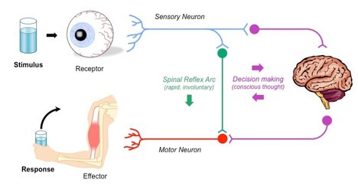The reflex arc is a neural pathway that controls a reflex. This sequence follows the stimulus response starting at the sensory receptors, however by passes the brain to have a quicker response time, and then straight to the motor receptors resulting in unconscious/involuntary actions with quick response times in order to keep the human body safe.